Back in the IDE, create a break point, and start the debugging process, take a screenshot of your progress and paste into the Word document.

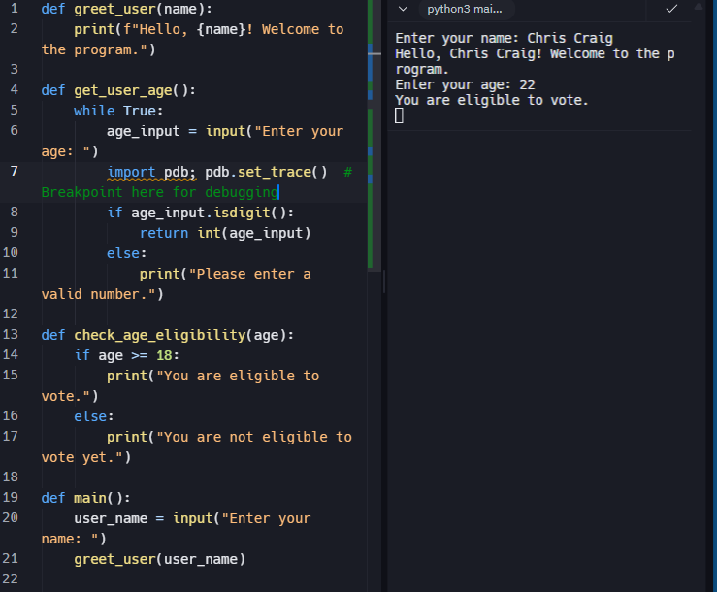

* Use at least one more action in the code, either adding errors, or moving through the program and take a screenshot of the progress and paste into the Word document.

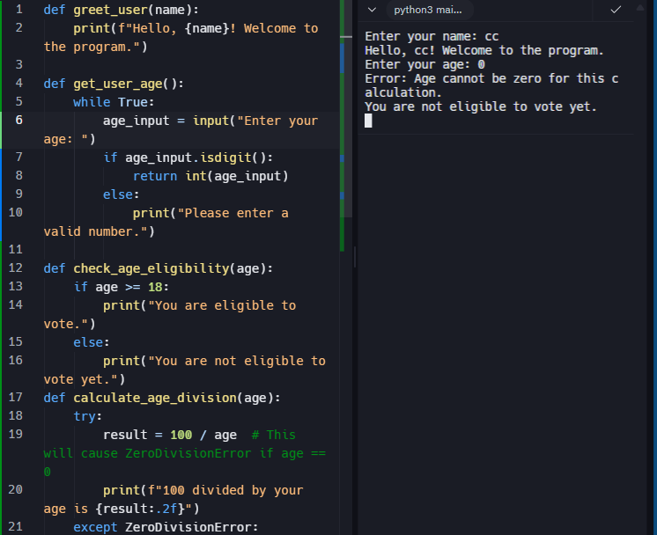

<https://replit.com/@chrcraig/Can-you-vote?v=1>

<https://github.com/LuvChris03/module-12-remake.git>